Design patterns RESUME – activity list

## 20220710

1. **~~Finishing the implementation of the view code section of every example pages (if they got one)~~**

**~~(without the marking service)~~**

1. **~~Finishing the implementation of the view code section of every example pages adding the Wrong Example page (with the marking service from the opened console)~~**
2. **~~Implementation of a more efficient service for visualizing the text (with marked lines examples)~~**
3. **Find a way to hightlights also the parts in the text description (maybe with special characters in the DB which identify the terms**
4. **~~Completing the example for the Strategy pattern~~**
5. **Going on in the implementation of every other pattern already in the DB**
6. **~~NB: remember to have the view and methods implemented by it, separated from the context of model (passing only the viewBag object instead)~~**
7. **NB: for the design pattern BUILDER 2 examples has to be shown in this page: the one related to OldRobotBuilder and the second to the OldRobotBuilder_2:**

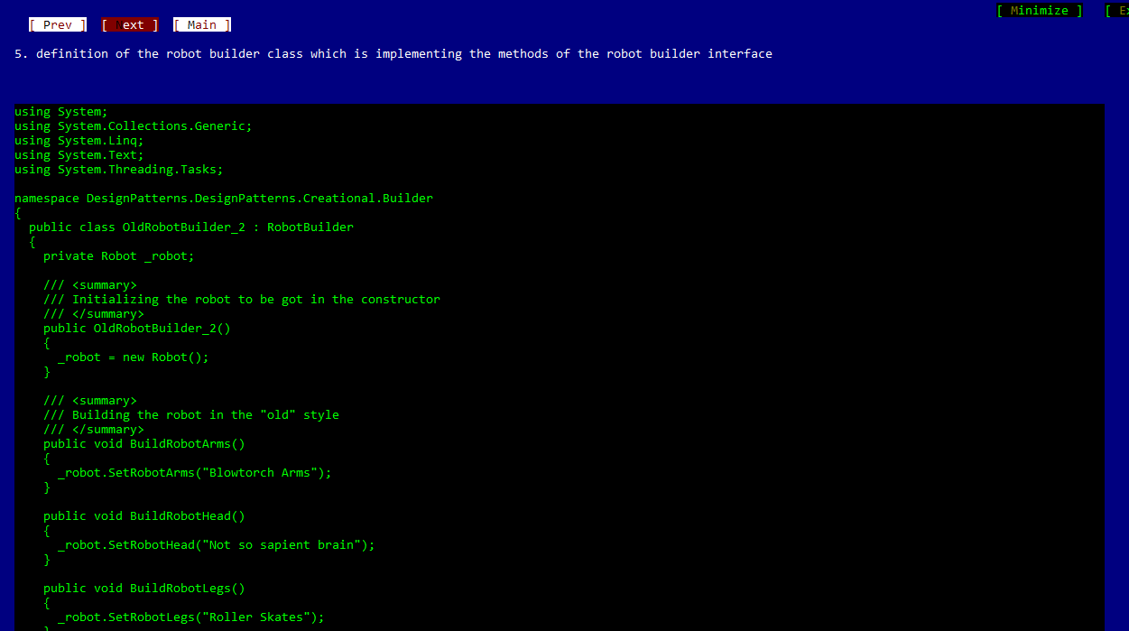

1. **Try to understand why for some pages the visualization with the scrollbar is interrupted (the example is clear but having the scrollbar will be better … ) (this is the case of the ADAPTER at step 2):**

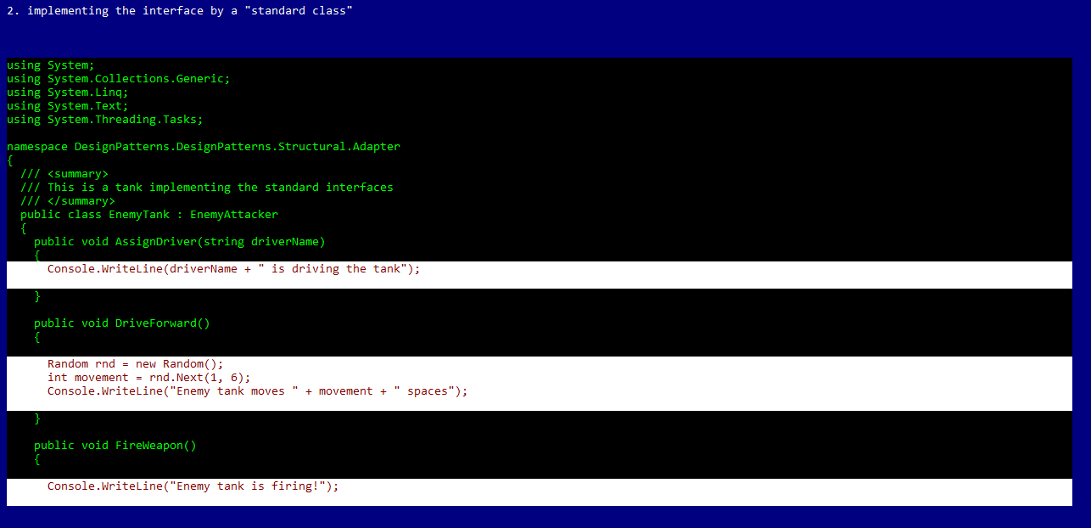

1. **For the chain of responsibility in this page:**

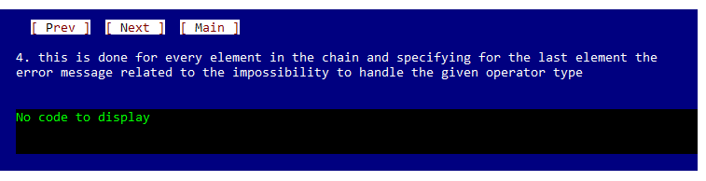

**I have to show every implementation of the elements in the chain (maybe with a tab element…)**

1. **Chain of responsibilty DEMO: it would be nice if there are the possibility to digit some parameters by the user at the end of the demo**
2. **The same for the BRIDGE: at page:**

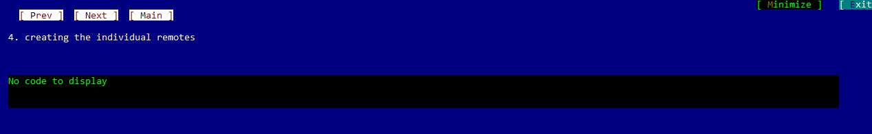

* **2 descriptions should be shown**

1. **In the BRIDGE the other example said the homework should be implemented**